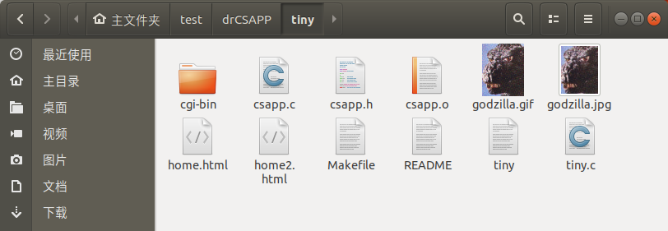

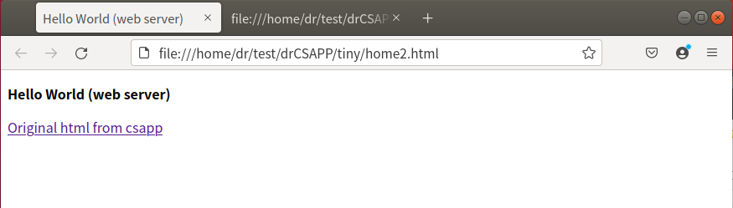

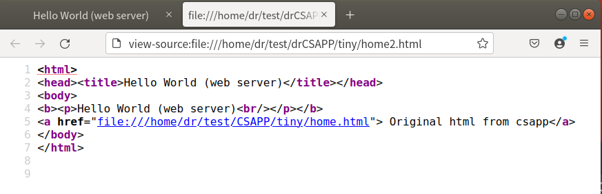
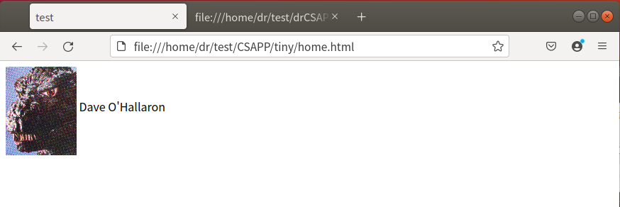

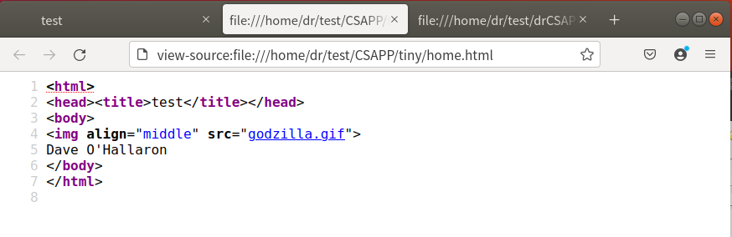

http://127.0.0.1:9000/

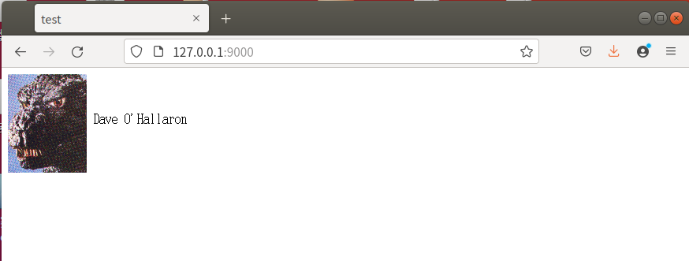

http://127.0.0.1:9000/home2.html
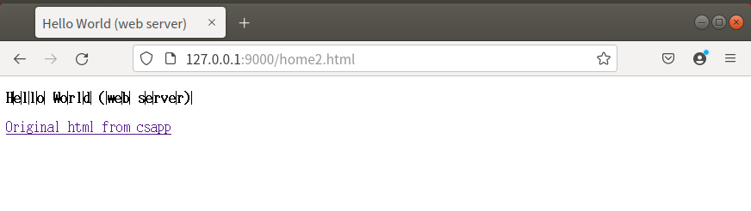

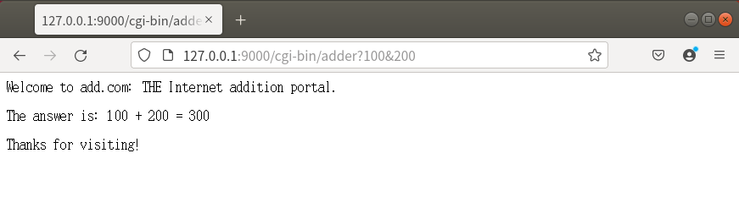
http://127.0.0.1:9000/cgi-bin/adder?100&200

